**TASK 1:**

<!doctype html>

<html lang="en">

  <head>

    <meta charset="utf-8">

    <meta name="viewport" content="width=device-width, initial-scale=1">

    <title>Bootstrap</title>

    <link href="https://cdn.jsdelivr.net/npm/bootstrap@5.3.2/dist/css/bootstrap.min.css" rel="stylesheet" integrity="sha384-T3c6CoIi6uLrA9TneNEoa7RxnatzjcDSCmG1MXxSR1GAsXEV/Dwwykc2MPK8M2HN" crossorigin="anonymous">

    <style>

        a{

            text-decoration: none;

        }

.container-fluid{

    background-color: white;

}

    </style>

  </head>

  <body>

    <div class="container-fluid">

        <a href="https://www.w3schools.com/bootstrap/bootstrap_ver.asp">

        <div class="bg-success text-success bg-opacity-50 s">Fell good about bootstrap</div> </a>

        <a href="https://www.w3schools.com/bootstrap/bootstrap_ver.asp">

        <div class="text-success bg-primary bg-opacity-25 s">Fell good about bootstrap</div></a>

        <a href="https://www.w3schools.com/bootstrap/bootstrap_ver.asp">

        <div class="text-warning bg-warning bg-opacity-25 s">Fell good about bootstrap</div></a>

        <a href="https://www.w3schools.com/bootstrap/bootstrap_ver.asp">

        <div class="text-warning bg-warning bg-opacity-25 s">Fell good about bootstrap</div></a>

        <a href="https://www.w3schools.com/bootstrap/bootstrap_ver.asp">

        <div class="bg-danger text-danger bg-opacity-25 s" >Fell good about bootstrap</div></a>

        <a href="https://www.w3schools.com/bootstrap/bootstrap_ver.asp">

        <div class="bg-danger text-danger bg-opacity-25 s">Fell good about bootstrap</div></a>

    </div>

    <script src="https://cdn.jsdelivr.net/npm/bootstrap@5.3.2/dist/js/bootstrap.bundle.min.js" integrity="sha384-C6RzsynM9kWDrMNeT87bh95OGNyZPhcTNXj1NW7RuBCsyN/o0jlpcV8Qyq46cDfL" crossorigin="anonymous"></script>

  </body>

</html>

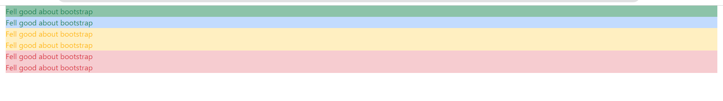

**TASK 2:**

<!doctype html>

<html lang="en">

  <head>

    <meta charset="utf-8">

    <meta name="viewport" content="width=device-width, initial-scale=1">

    <title>Bootstrap</title>

    <link href="https://cdn.jsdelivr.net/npm/bootstrap@5.3.2/dist/css/bootstrap.min.css" rel="stylesheet" integrity="sha384-T3c6CoIi6uLrA9TneNEoa7RxnatzjcDSCmG1MXxSR1GAsXEV/Dwwykc2MPK8M2HN" crossorigin="anonymous">

    <style>

        .container-fluid{

    background-color: khaki;

}

    </style>

  </head>

  <body>

    <div class="container-fluid">

        <button type="button" class="btn">Basic</button>

        <button type="button" class="btn btn-primary">Primary</button>

        <button type="button" class="btn btn-secondary">Secondary</button>

        <button type="button" class="btn btn-success">Success</button>

        <button type="button" class="btn btn-info">Info</button>

        <button type="button" class="btn btn-warning">Warning</button>

        <button type="button" class="btn btn-danger">Danger</button>

        <button type="button" class="btn btn-dark">Dark</button>

        <button type="button" class="btn btn-light">Light</button>

        <button type="button" class="btn btn-link">Link</button>

    </div>

   <script src="java.js"></script>

    <script src="https://cdn.jsdelivr.net/npm/bootstrap@5.3.2/dist/js/bootstrap.bundle.min.js" integrity="sha384-C6RzsynM9kWDrMNeT87bh95OGNyZPhcTNXj1NW7RuBCsyN/o0jlpcV8Qyq46cDfL" crossorigin="anonymous"></script>

  </body>

</html>

let buttons = document.getElementsByClassName("btn");

for (let i = 0; i < buttons.length; i++) {

    buttons[i].addEventListener("click", function() {

        alert("My name is Zain UL Waqas");

    });

}



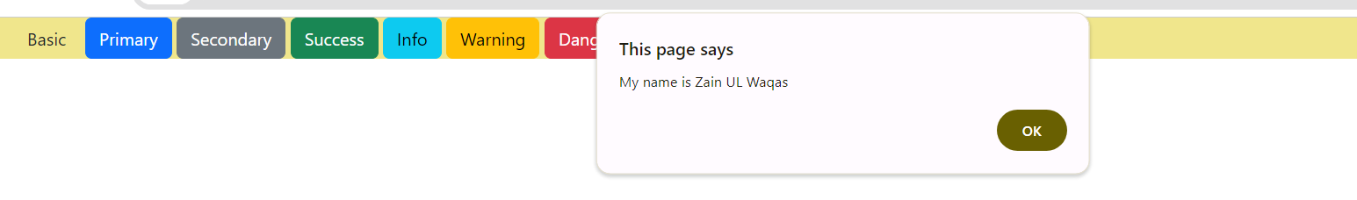

**TASK 3:**

<!doctype html>

<html lang="en">

  <head>

    <meta charset="utf-8">

    <meta name="viewport" content="width=device-width, initial-scale=1">

    <title>Bootstrap</title>

<link href="https://cdn.jsdelivr.net/npm/bootstrap@5.3.2/dist/css/bootstrap.min.css" rel="stylesheet" integrity="sha384-T3c6CoIi6uLrA9TneNEoa7RxnatzjcDSCmG1MXxSR1GAsXEV/Dwwykc2MPK8M2HN" crossorigin="anonymous">

  </head>

  <body>

    <input id="r1" name="qw" placeholder="Num 1" />

    <input id="r2"  name="qw" placeholder="Num 2" />

    <input id="rr"  name="qw" placeholder="ANS" />

    <br>

    <button id="r3" onclick="fun()" >Add</button>

    <button id="r4" onclick="fun1()">Sub</button>

    <button id="r5" onclick="fun2()">Mul</button>

    <button id="r6" onclick="fun3()">Div</button>

    <script src="java.js"></script>

    <script src="https://cdn.jsdelivr.net/npm/bootstrap@5.3.2/dist/js/bootstrap.bundle.min.js" integrity="sha384-C6RzsynM9kWDrMNeT87bh95OGNyZPhcTNXj1NW7RuBCsyN/o0jlpcV8Qyq46cDfL" crossorigin="anonymous"></script>

  </body>

</html>

let buttons = document.getElementById("r3");

let fun = ()=>{

    let i1 = Number(document.getElementById("r1").value);

    let i2 = Number(document.getElementById("r2").value);

    console.log(i1+i2);

    document.getElementById("rr").value=(i1+i2)

}

let fun1 = ()=>{

    let i1 = Number(document.getElementById("r1").value);

    let i2 = Number(document.getElementById("r2").value);

    console.log(i1-i2);

    document.getElementById("rr").value=(i1-i2)

}

let fun2 = ()=>{

    let i1 = Number(document.getElementById("r1").value);

    let i2 = Number(document.getElementById("r2").value);

    console.log(i1*i2);

    document.getElementById("rr").value=(i1*i2)

}

let fun3 = ()=>{

    let i1 = Number(document.getElementById("r1").value);

    let i2 = Number(document.getElementById("r2").value);

    console.log(i1/i2);

    document.getElementById("rr").value=(i1/i2)

}

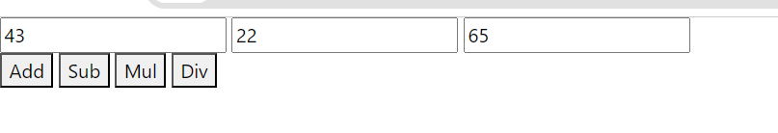

**TASK 4:**

<!doctype html>

<html lang="en">

  <head>

    <meta charset="utf-8">

    <meta name="viewport" content="width=device-width, initial-scale=1">

    <title>Bootstrap</title>

<link href="https://cdn.jsdelivr.net/npm/bootstrap@5.3.2/dist/css/bootstrap.min.css" rel="stylesheet" integrity="sha384-T3c6CoIi6uLrA9TneNEoa7RxnatzjcDSCmG1MXxSR1GAsXEV/Dwwykc2MPK8M2HN" crossorigin="anonymous">

    <style>

        .container-fluid{

    background-color: white;

}

#e1{

    color: peru;

}

    </style>

  </head>

  <body>

    <input id="r1" name="qw" type="text" placeholder="Enter month name" />

    <h1 id="e1"></h1>

    <button id="r6" onclick="fun3()">Submit</button>

    <script src="java.js"></script>

    <script src="https://cdn.jsdelivr.net/npm/bootstrap@5.3.2/dist/js/bootstrap.bundle.min.js" integrity="sha384-C6RzsynM9kWDrMNeT87bh95OGNyZPhcTNXj1NW7RuBCsyN/o0jlpcV8Qyq46cDfL" crossorigin="anonymous"></script>

  </body>

</html>

let fun3 = ()=>{

    let day = 0;

    let i1 = document.getElementById("r1").value;

    if(i1=="January" || i1=="March" || i1=="May" || i1=="July" || i1=="August" || i1=="October" || i1=="December")

    {

        day = 31;

    }

    else if(i1=="April" || i1=="June" || i1=="September" || i1=="November")

    {

        day=30;

    }

    else if(i1=="February")

    {

        day=28;

    }

    document.getElementById("e1").innerHTML=`${day}`

}

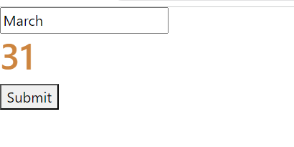

**TASK 5:**

<!doctype html>

<html lang="en">

  <head>

    <meta charset="utf-8">

    <meta name="viewport" content="width=device-width, initial-scale=1">

    <title>Bootstrap</title>

<link href="https://cdn.jsdelivr.net/npm/bootstrap@5.3.2/dist/css/bootstrap.min.css" rel="stylesheet" integrity="sha384-T3c6CoIi6uLrA9TneNEoa7RxnatzjcDSCmG1MXxSR1GAsXEV/Dwwykc2MPK8M2HN" crossorigin="anonymous">

  <style>

    .by{

        background-color: gray;

    }

  </style>

</head>

  <body>

    <input id="r1" name="qw" type="Number" placeholder="Enter month name" />

    <h1 id="e1"></h1>

    <button class="by" id="r6" onclick="fun3()">Submit</button>

    <script src="java.js"></script>

    <script src="https://cdn.jsdelivr.net/npm/bootstrap@5.3.2/dist/js/bootstrap.bundle.min.js" integrity="sha384-C6RzsynM9kWDrMNeT87bh95OGNyZPhcTNXj1NW7RuBCsyN/o0jlpcV8Qyq46cDfL" crossorigin="anonymous"></script>

  </body>

</html>

let fun3 = ()=>{

    let i1 = Number(document.getElementById("r1").value);

    let r = document.createElement("div");

    r.classList.add("e1");

    for(let i=1;i<=10;i++)

    {

        let r1 = document.createElement("h2");

        let r3 = i1 * i;

        r1.innerHTML = `${i1} * ${i} = ${r3}`;

        r1.style.color="peru";

        r.appendChild(r1);

    }

    document.getElementById("e1").appendChild(r);

}

